Lesson-8 चुलबुल हिरन

QUESTION AND ANSWER
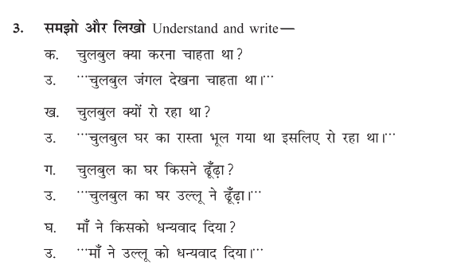

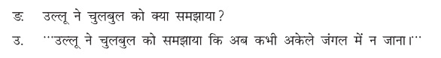
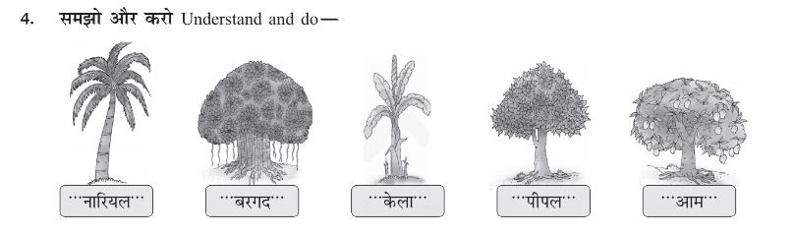
Write the name of tree in Hindi.

Coconut Banyan Banana Peepal Mango

